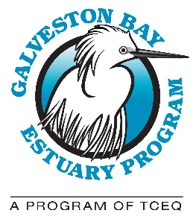

GALVESTON BAY COUNCIL QUARTERLY MEETING
Location: Meet for field trip at Challenger 7 Memorial Park, 2301 W. Nasa Blvd., Webster, TX 77598

AGENDA: Wednesday, April 12, 2022

8:30 A.M.: Call to Order

Action Item: Approval of July 21, 2021 Meeting Minutes

Report of the Program (Lisa Marshall)

Announcement: Introduction of Matthew Abernathy, Education and Outreach Coordinator

Report of the Chair (Glenn Clingenpeel)

8:40 A.M.: Council Member Roundtable: News, Announcements and Discussion

8:50 A.M.: Public comments

9:00 A.M.: Adjourn
Upcoming Galveston Bay Council Meeting Dates: July 20, 2022; and October 19, 2022. Meetings are held on the third Wednesday of the quarter from 9:30 A.M. – 12:30 P.M. If there are known conflicts, Council members are welcome to propose alternate dates to the Council.

