Galveston Bay Council Field Trip and Itinerary
April 20, 2022

8:30 am: Arrival at Challenger 7 Memorial Park** (30 min)
2301 W Nasa Blvd
Webster, TX 77598

**Choice to arrive early and walk boardwalks for Clear Creek Riparian Restoration Project

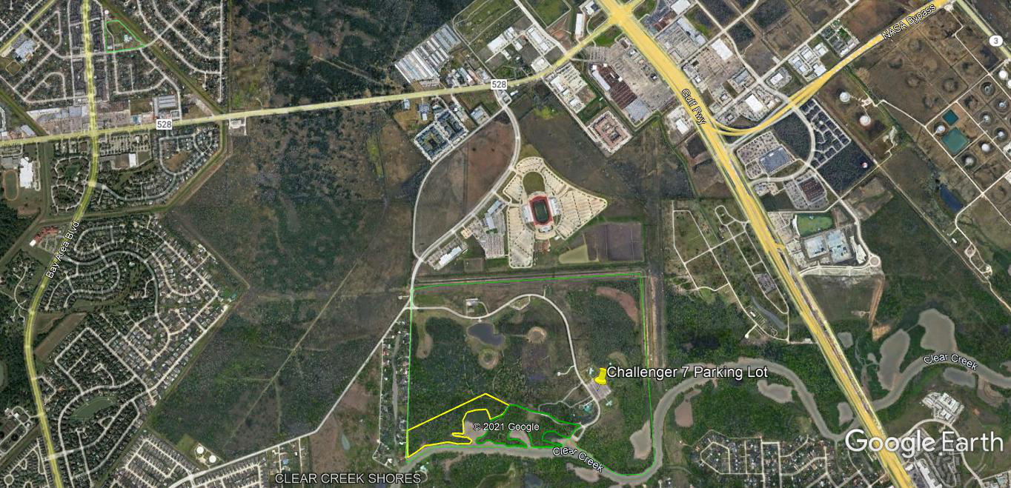

9:00 am: Depart Challenger 7 Park for Coastal Heritage Preserve (40min-1hr travel time)

10:00 am Arrive at Coastal Heritage Preserve (30 min)
12816 Concho
Galveston, TX 77554

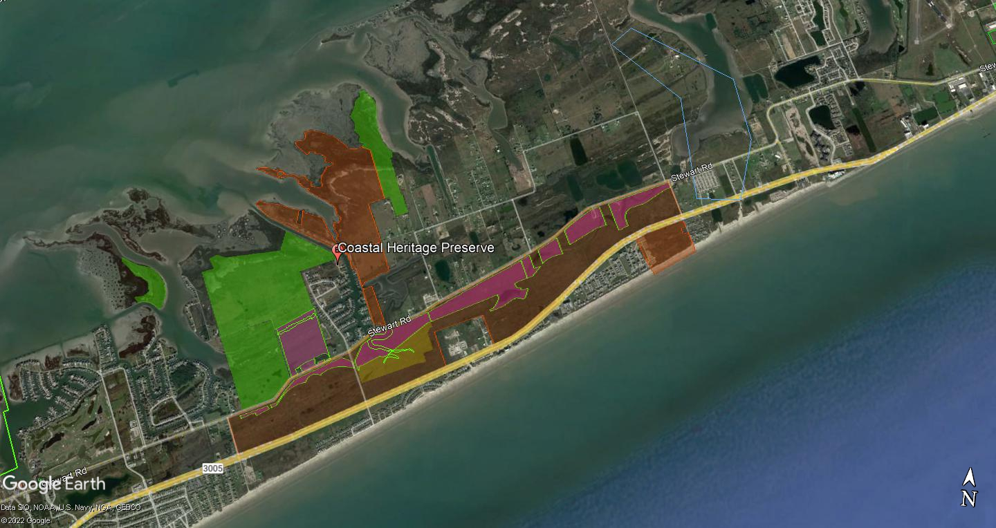
10:30 am: Depart Coastal Heritage Preserve for Galveston Island State Park (5-10min travel time)

10:40 am Arrive at Galveston Island State Park (20min)
14901 FM3005
Galveston, TX 77554

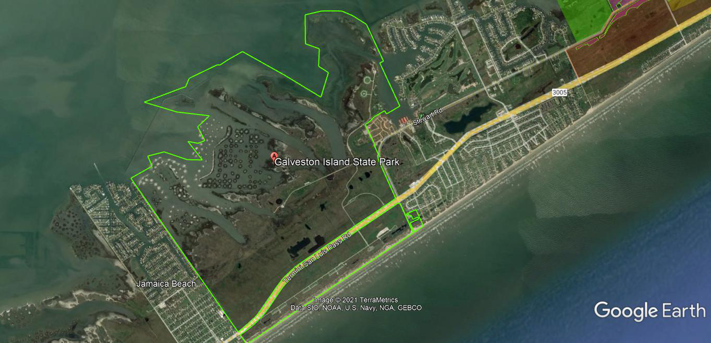

11:00 am: Depart Galveston Island State Park for Exploration Green (55min-1hr 10min travel time)

12:10 pm Arrive at Exploration Green (20 min)
16205 Diana Ln
Houston, TX 77062

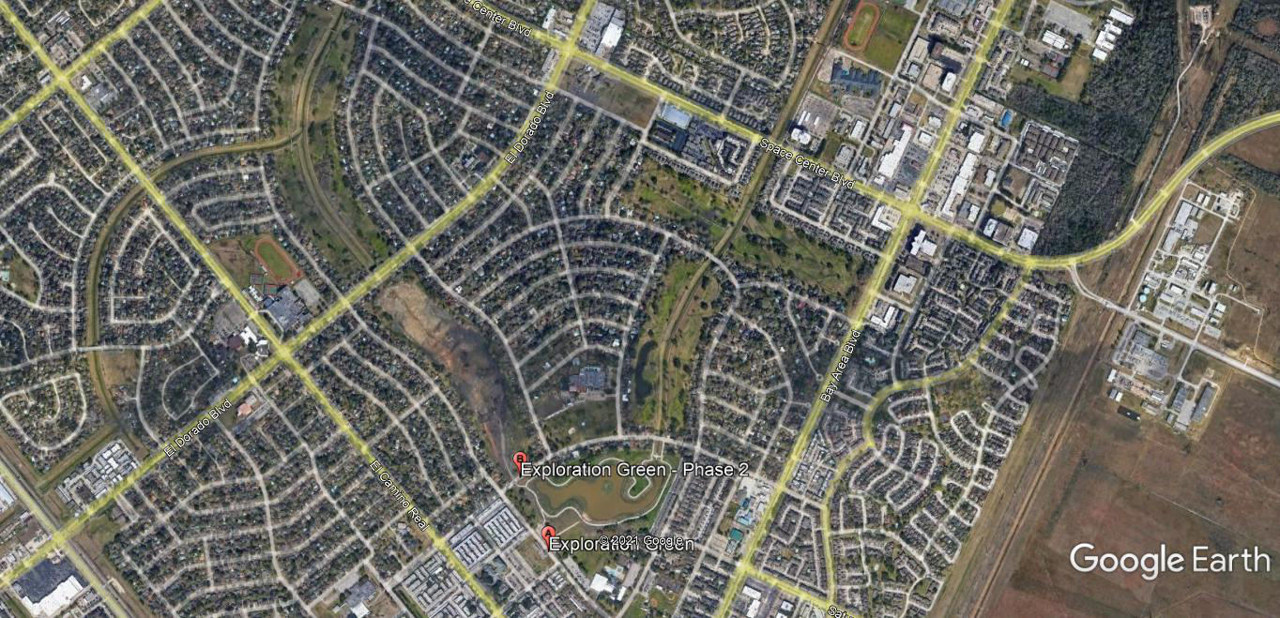

12:30 pm: Depart Exploration Green for Challenger 7 Memorial Park (15-20min travel time)

12:50 pm: Arrive at Challenger 7 Memorial Park** (30 min)
2301 W Nasa Blvd
Webster, TX 77598

**Choice to depart or walk boardwalks for Clear Creek Riparian Restoration Project

