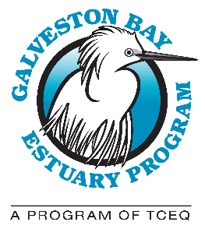

GALVESTON BAY COUNCIL QUARTERLY MEETING
Location: Harris-Galveston Subsidence District, 1660 West Bay Area Blvd, Friendswood, TX 77546-2640, (281) 486-1105. Virtually – Microsoft Teams

AGENDA: Wednesday, April 19, 2023

9:30 A.M.: Call to Order: Introduction of Members and Delegates

Action Item: Approval of January 18, 2023 Meeting Minutes

Report of the Program (Lisa Marshall)

Report of the Chair (Glenn Clingenpeel)

- Discussion of Third Year of BIL Funding

Action Item: Approval of Juan Flores, Underrepresented Communities

9:50 A.M.: Presentation: Galveston Bay Estuary Resilience Action Plan: Overview – Stephanie Glenn, Ph.D. and Erin Kinney, Ph.D., Houston Advanced Research Center

10:30 A.M.: Break

10:45 A.M.: Presentation: The Luce Bayou Interbasin Transfer Project – David Miller, Coastal Water Authority

11:25 A.M.: Presentation: Occurrence of Microplastics in Tributaries of Galveston Bay - Zulimar Lucena, United States Geological Survey

12:00 P.M.: Council Member Roundtable: News, Announcements, and Discussion

12:15 P.M.: Public comments

12:30 P.M.: Adjourn
Upcoming Galveston Bay Council Meeting Dates: July 19, 2023, October 18, 2023, January 17, 2024, and April 17, 2024. Meetings are held on the third Wednesday of the quarter from 9:30 a.m. – 12:30 p.m. If there are known conflicts, Council members are welcome to propose alternate dates to the Council.

