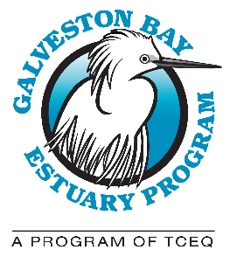

GALVESTON BAY COUNCIL QUARTERLY MEETING
Location: Harris-Galveston Subsidence District, 1660 West Bay Area Blvd, Friendswood, TX 77546-2640, (281) 486-1105. Virtually – Microsoft Teams

AGENDA: Wednesday, January 18, 2023

9:30 A.M.: Call to Order: Introduction of Members and Delegates

Action Item: Approval of October 19, 2022 Meeting Minutes

Report of the Program (Lisa Marshall)

Report of the Chair (Glenn Clingenpeel)

9:50 A.M.: Presentation: Updates on Port Houston and Ship Channel Expansion - Charlie Jenkins, and Trae Camble, Port Houston

10:30 A.M.: Presentation: Texas Legislative Overview – Amy Stetler, Trinity River Authority

11:00 A.M.: Break

11:15 A.M.: Presentation: Planning for Healthy Soils – Brian Koch, Texas State Soil and Water Conservation Board

12:00 P.M.: Council Member Roundtable: News, Announcements and Discussion

12:15 P.M.: Public comments

12:30 P.M.: Adjourn
Upcoming Galveston Bay Council Meeting Dates: January 18, 2023, April 19, 2023, July 19, 2023, and October 18, 2023. Meetings are held on the third Wednesday of the quarter from 9:30 a.m. – 12:30 p.m. If there are known conflicts, Council members are welcome to propose alternate dates to the Council.

