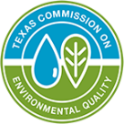
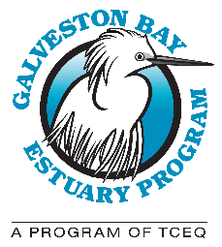
WATER AND SEDIMENT QUALITY SUBCOMMITTEE

GALVESTON BAY COUNCIL

Meeting Minutes

Wednesday, September 9, 2026

1:00PM – 3:30PM

Subcommittee Chair: Brian Koch, Texas State Soil and Water Conservation Board (TSSWCB)

Subcommittee Vice Chair: Ryan Bare, Houston Advanced Research Center (HARC)

GBEP Representative: Christian Rines

Call to Order
Attendees: Brian Koch (TSSWCB), Ryan Bare (HARC), Christian Rines (GBEP), Steven Johnston (H-GAC), Erin Kinney (HARC), Amanda Hackney (Black Cat GIS), Jenny Oakley (H-GAC), George Guillen (UHCL), Hanadi Rifai (UH), Michael LaMontagne (UHCL), Cesar Garcia (City of Kemah), Katie Wilson (GCHD), Christie Taylor (TX A&M AgriLife), Lauren Kennedy (UTEP), Luke Travis (USGS), Austin Perez (Willow Waterhole Greenway), Zulimar Lucena (USGS), Asif Mortuza (UHCL), David Villarreal (TDA), Rachel Windham (H-GAC), Mandi Gordon (UHCL), Sam Hill (TFS), Kendall Guidroz (H-GAC), Cornell Evans (H-GAC), Jennifer Irving (HARC), Nicole Hall (TCEQ), Grant Moss (HPARD), Ryan Ono (Texas GLO), Sandra Metoyer (Friends of FGB), Natasha Zarnstorff (GBF), Marissa Llosa (HPB), Megha Shrestha (H-GAC), Linda Shead (Various Non-Profits), Tom Douglas (Various Non-Profits), Laura Ryckman (TCEQ), Brittani Flowers (BPA), Nicholas Kosmas (Buckson LA), Faith Hambleton (TCEQ), Huy Vu (EPA), Lisa Marshall (GBEP), Lindsey Lippert (GBEP), Hope Cole (GBEP), Jenelle Estrada (GBEP), Celina Gauthier Lowry (GBEP), and Zoe Gapayao (GBEP).

Approval of the June 10, 2026 minutes – Ms. Rines opened the meeting with approval of the minutes. Mr. Koch motioned to approve the minutes, and Ms. Oakley seconded the motion. The minutes were approved with no changes.

A Conflict-of-Interest statement was provided to in-person attendees and emailed to those attending online. Subcommittee members were asked to sign the statement and disclose any interest with a proposed project prior to or during the project nomination discussion. All possible conflicts of interest were captured in the meeting’s recording and chat feature.

New Business
Fiscal 2028 Project Proposals and Discussion
Project proposals were sent out in advance of the meeting for review. Members were asked to keep the subcommittee priorities in mind while reviewing. Priorities selected by the WSQ Subcommittee for the Fiscal 2028 funding cycle were as follows:
- Supporting management measures and watershed-based plans through adaptive management, workforce development, and technical assistance.
- Improve knowledge and accessibility of pollution reporting tools to empower the community.
- Implementation and/or evaluation of best management practices that address point and nonpoint source pollution.

Each person presenting a proposal was given a total of five minutes to explain their project followed by a few minutes for Q&A. Guidelines for presenting proposals were as follows:

- Due to time constraints, presentations were limited to a few slides;
- Proposals were presented in the order of the distributed project proposal packet;
- If a connection to a proposal was not obvious, the relationship to the project was disclosed; and,
- If a vote was necessary, only one person from each entity could vote and represent their entity.

Once all proposals were presented, the subcommittee discussed which of the projects should be recommended to the Budget and Priorities (B&P) Subcommittee for funding. Four projects have been advanced to B&P for consideration. These projects are unranked, with final approval subject to available funding, concurrent subcommittee input, and the ultimate recommendation of B&P. Due to time constraints, a ranking sheet was distributed for the remaining six projects; eligible voting members were asked to rank them as alternates in the event that additional funding becomes available. The WSQ subcommittee’s recommendation for FY28 projects is found in the table below.
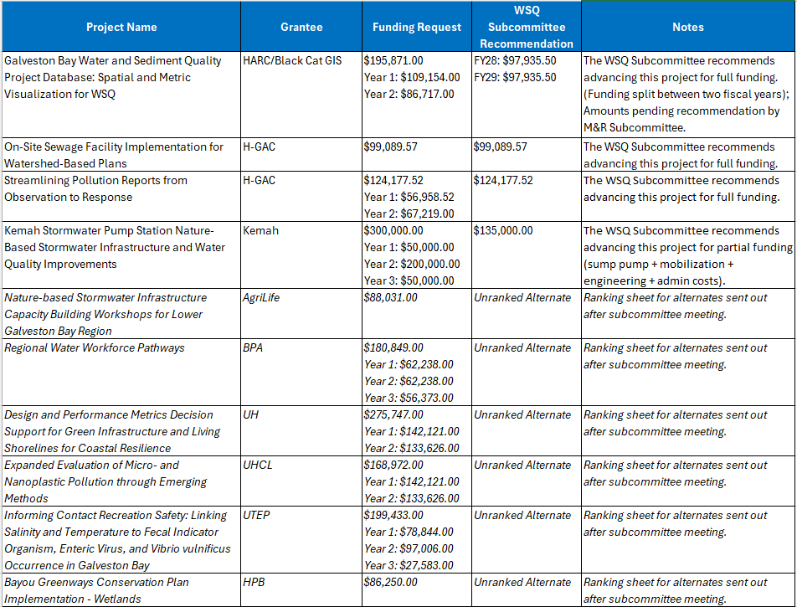

Old Business

Project Updates from WSQ Project Mangers:
*Time did not allow for project updates.
Watershed Partnership Updates/Roundtable:
*Time did not allow for partner updates.

Galveston Bay Estuary Program, Council, and Subcommittee updates:
*Time did not allow for GBEP updates.

Upcoming GBEP meetings:
- B&P Meeting – Wednesday, September 30, 2026 (1:00pm -3:00pm)
- GBC Meeting – Wednesday, October 14, 2026 (9:30am -12:30pm)
- Next WSQ Subcommittee Meeting – Wednesday, December 9, 2026 (1:30-3:30pm)

Adjourn

